**ARYAMAN MISHRA**

**19BCE1027**

**LAB FAT**

(red font is input)

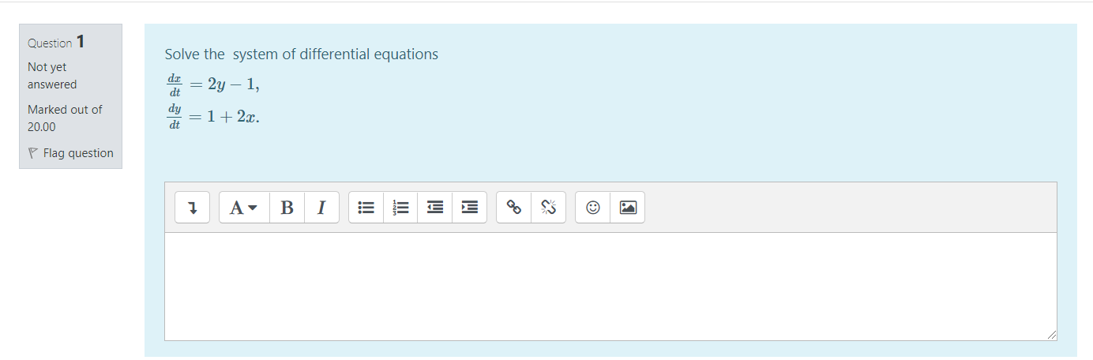

clc

clear all

syms t c1 c2

c=[c1 c2];

A=input('enter the matrix A in dy/dt=Ay+h:');

nh=input('enter nh as a row vector in dy/dt=Ay+h:');

n=length(A);

[P,D]=eig(A)

PP=inv(P)

g=PP(:,1)*nh(1)+PP(:,2)*nh(2)

for i=1:n

u(i)=c(i)*exp(D(i,i)*t)+(exp(D(i,i)*t)*int(g(i)*exp(-D(i,i)*t)));

end

y=simplify(P(:,1)*u(1)+P(:,2)*u(2))

disp('the solution vector is given by:')

disp(y)

enter the matrix A in dy/dt=Ay+h:

[0 2; 2 0]

enter nh as a row vector in dy/dt=Ay+h:

[-1;1]

P =  
  
 -0.7071 0.7071  
 0.7071 0.7071  
  
  
D =  
  
 -2 0  
 0 2  
  
  
PP =  
  
 -0.7071 0.7071  
 0.7071 0.7071  
  
  
g =  
  
 1.4142  
 0

y =  
   
(2^(1/2)*c2*exp(2*t))/2 - (2^(1/2)*(2^(1/2)/2 + c1*exp(-2*t)))/2  
(2^(1/2)*(2^(1/2)/2 + c1*exp(-2*t)))/2 + (2^(1/2)*c2*exp(2*t))/2  
   
the solution vector is given by:  
(2^(1/2)*c2*exp(2*t))/2 - (2^(1/2)*(2^(1/2)/2 + c1*exp(-2*t)))/2  
(2^(1/2)*(2^(1/2)/2 + c1*exp(-2*t)))/2 + (2^(1/2)*c2*exp(2*t))/2

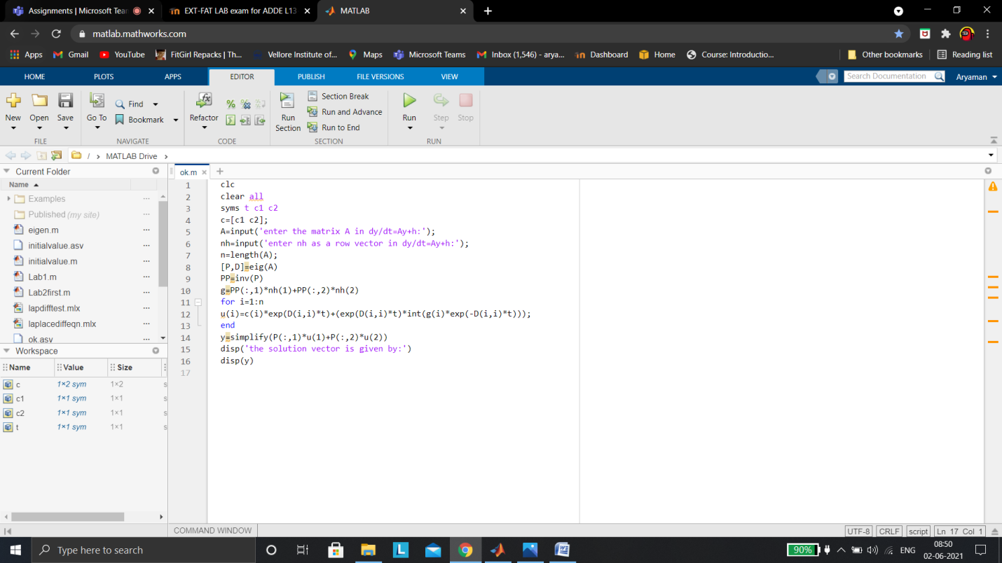



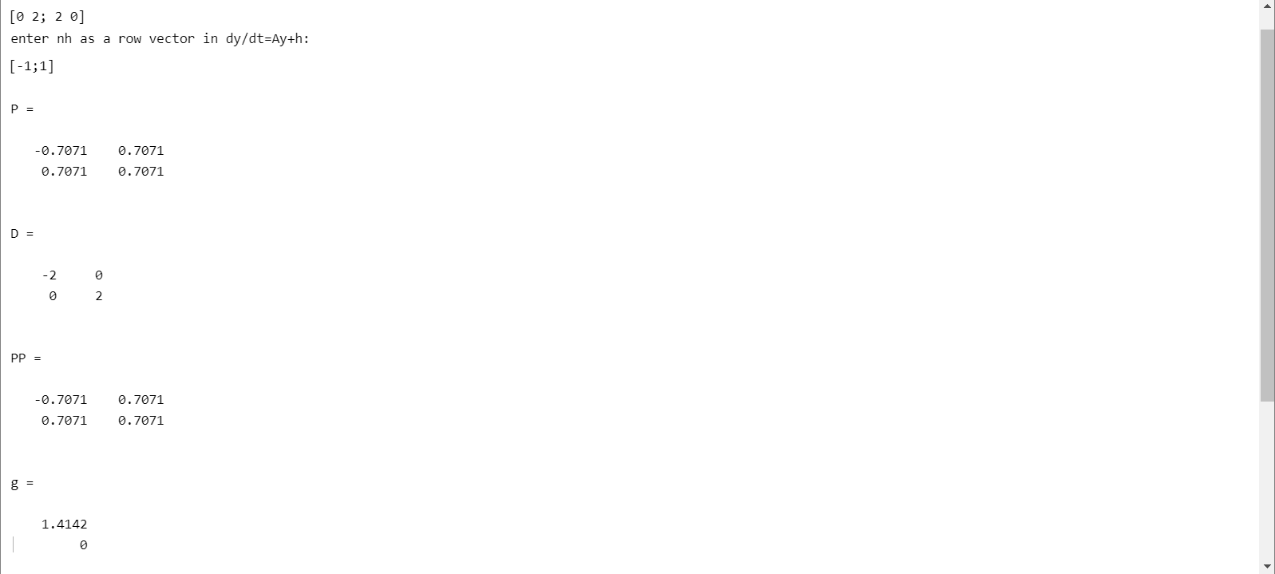

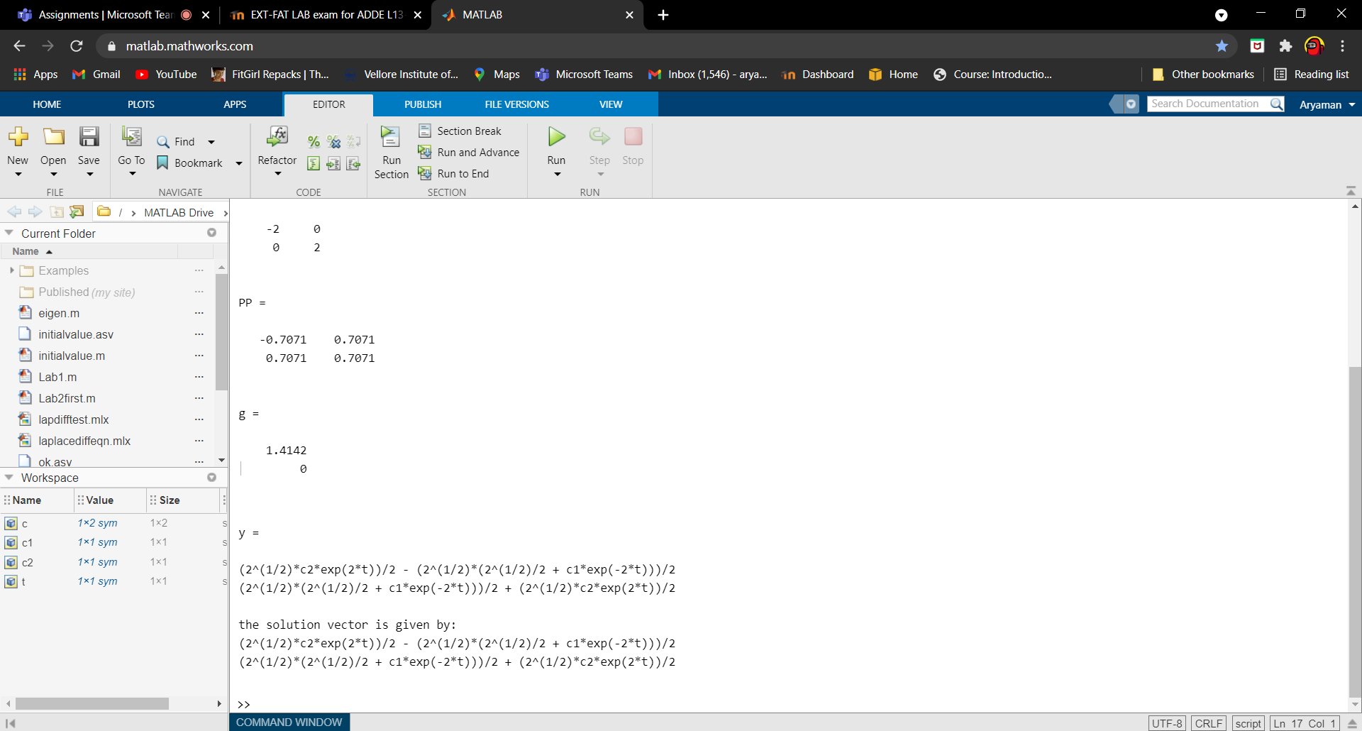

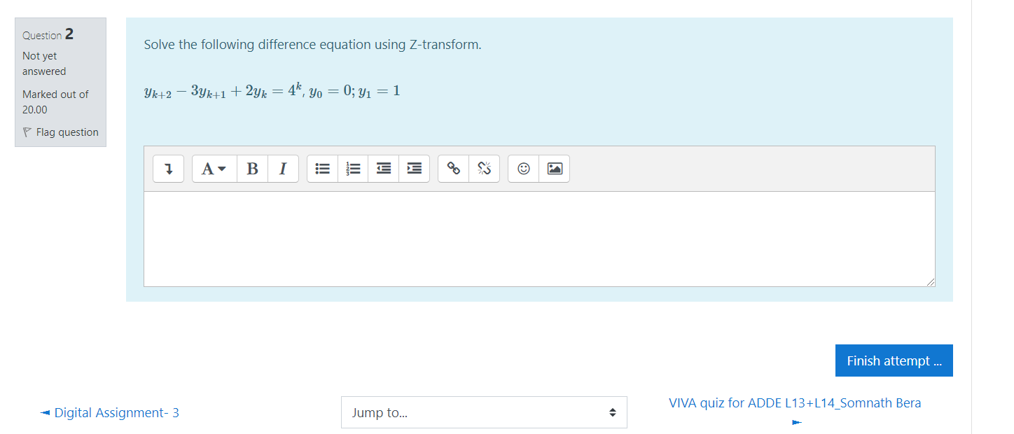

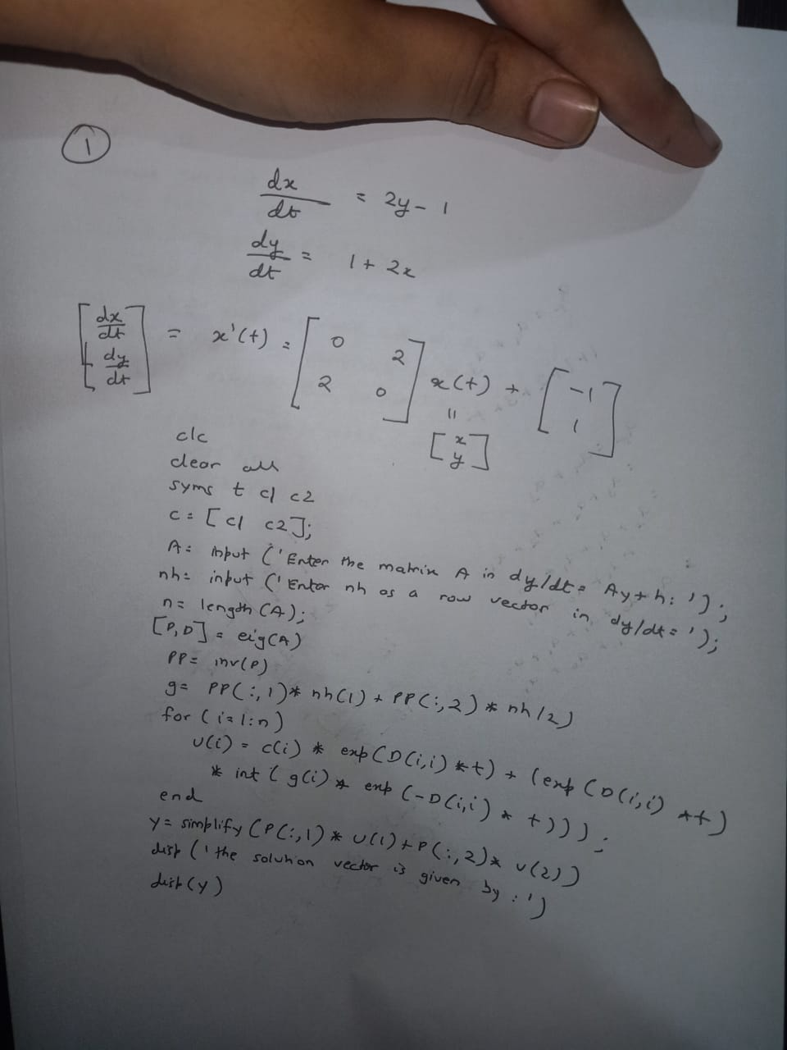

clc

clear all

format compact

syms p(n) z pZT

assume(n>=0 & in(n,'integer'))

a=input('Enter the coefficient of p_n+2:')

b=input('Enter the coefficient of p_n+1:')

c=input('Enter the coefficient of p_n:')

G=input('Enter the RHS function:') %non homogeneous part

f=a*p(n+2)+b*p(n+1)+c*p(n)-G

fZT = ztrans(f,n,z)

fZT = subs(fZT,ztrans(p(n),n,z),pZT)

pZT = solve(fZT,pZT)

pSol = iztrans(pZT,z,n)

pSol = simplify(pSol)

a=input('Enter the value of p_0:');

b=input('Enter the value of p_1:');

disp('Solution of the difference equation is given by:')

pSol= subs(pSol,[p(0) p(1)],[a b])

nValues = 1:10;

pSolValues = subs(pSol,n,nValues);

pSolValues = double(pSolValues);

pSolValues = real(pSolValues);

stem(nValues,pSolValues)

grid on

Enter the coefficient of p_n+2:

1

a =  
 1  
Enter the coefficient of p_n+1:

-3

b =  
 -3  
Enter the coefficient of p_n:

2

c =  
 2  
Enter the RHS function:

4^n

G =  
4^n  
f =

p(n + 2) - 3*p(n + 1) + 2*p(n) - 4^n

fZT =  
3*z*p(0) - 3*z*ztrans(p(n), n, z) - z/(z - 4) - z*p(1) + z^2*ztrans(p(n), n, z) - z^2*p(0) + 2*ztrans(p(n), n, z)  
fZT =  
2*pZT - z/(z - 4) + 3*z*p(0) - z*p(1) - 3*pZT*z - z^2*p(0) + pZT*z^2

pZT =  
(z/(z - 4) - 3*z*p(0) + z*p(1) + z^2*p(0))/(z^2 - 3*z + 2)

pSol =  
p(0)*kroneckerDelta(n, 0) - (kroneckerDelta(n, 0) - 1)*(2*p(0) - p(1) + 1/3) - (2^n/2 - kroneckerDelta(n, 0)/2)*(2*p(0) - 2*p(1) + 1) + 4^n/6 - kroneckerDelta(n, 0)/6

pSol =  
2*p(0) - p(1) + 2^(2*n)/6 - 2^n*p(0) + 2^n*p(1) - 2^n/2 + 1/3  
Enter the value of p_0:

0

Enter the value of p_1:

1

Solution of the difference equation is given by:  
pSol =  
2^(2*n)/6 + 2^n/2 - 2/3

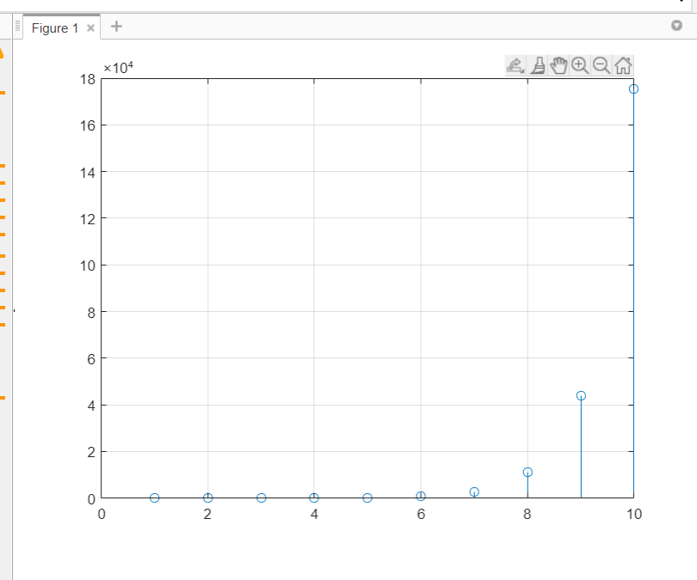

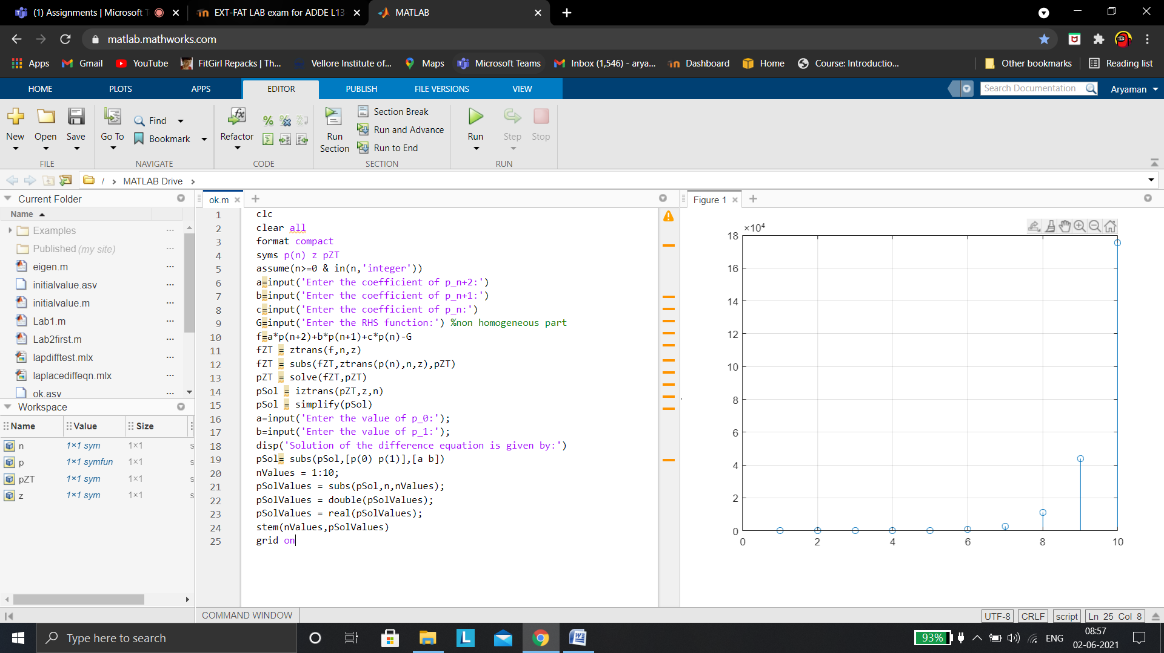

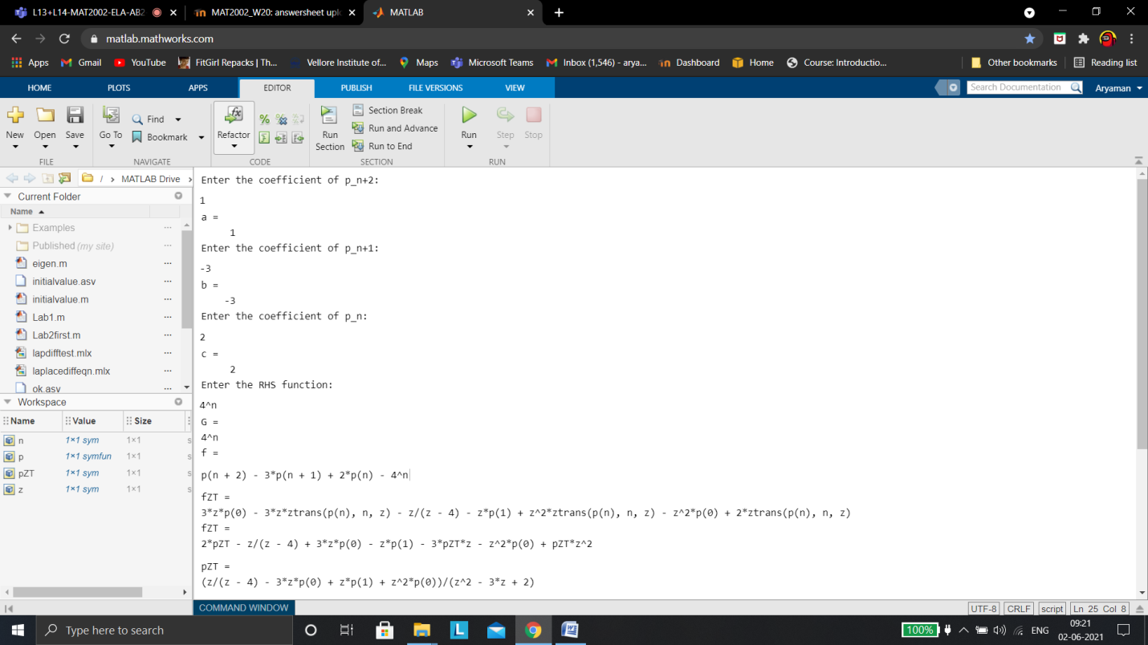

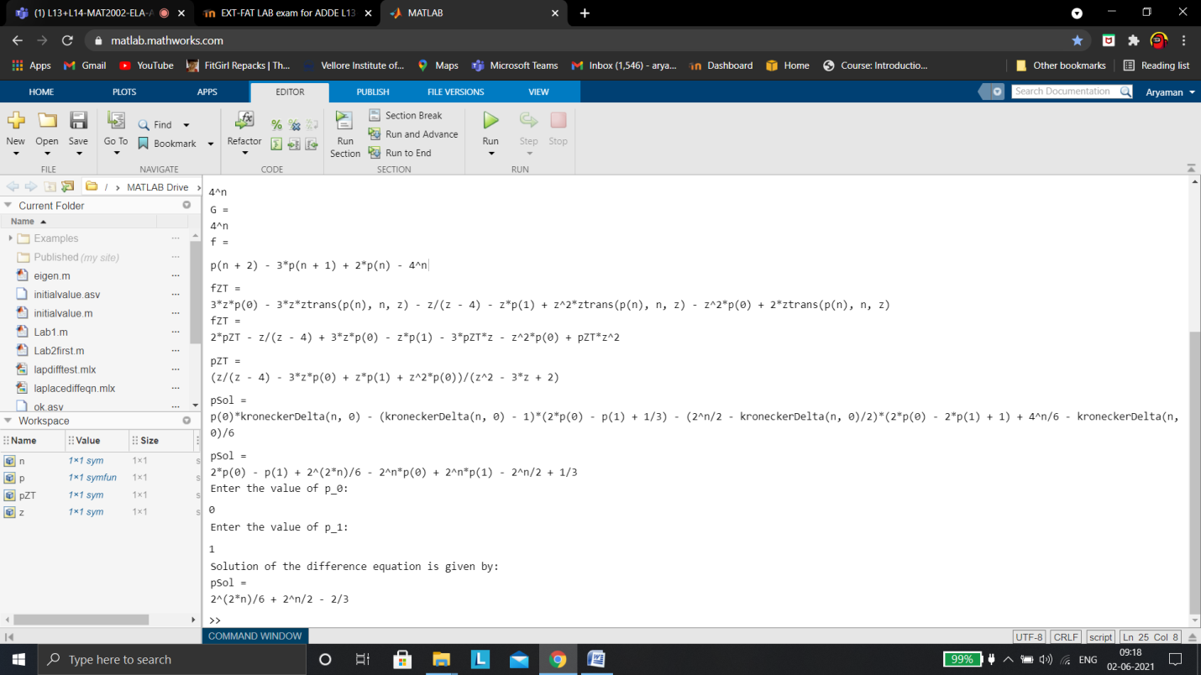

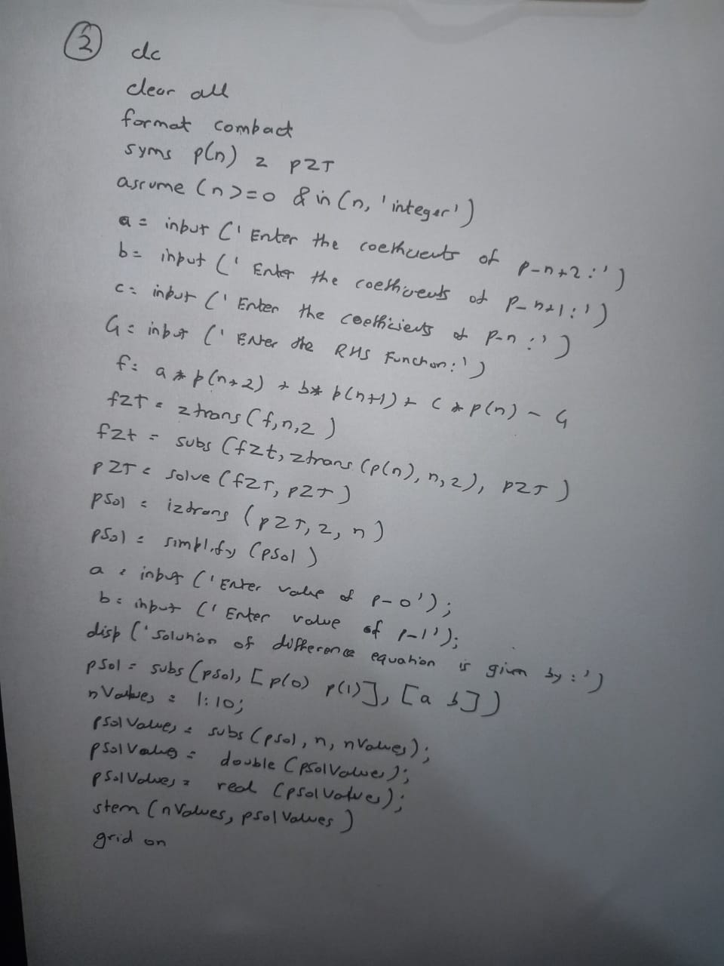

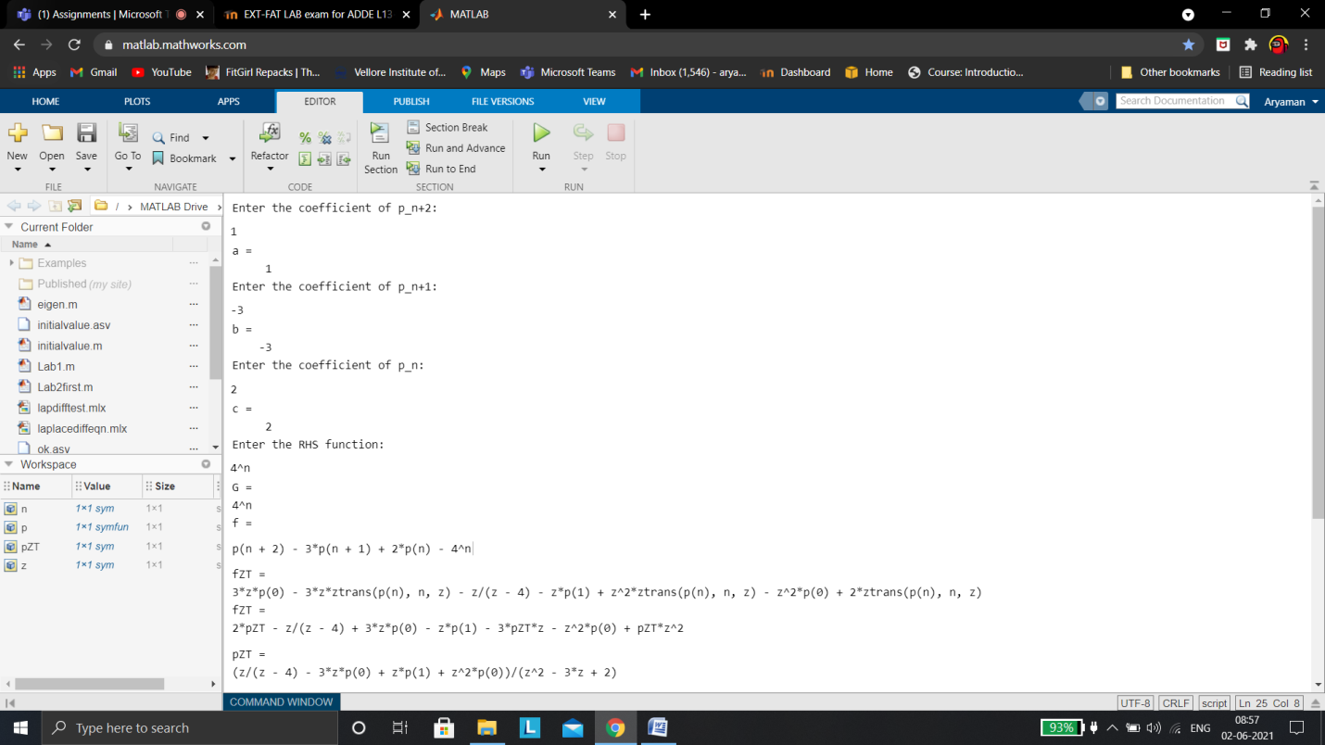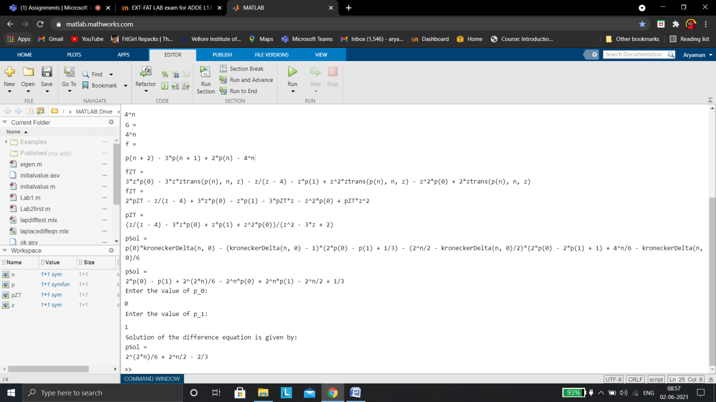  
quiz rough work

